Breadth First Search (BFS)

Aim
To implement Breadth First Search (BFS) algorithm using Python.
Objective
To traverse a graph level by level and find the path from a starting node to a goal node.
Algorithm
- Start from the given source node.
- Add the source node to the queue.
- Mark the source node as visited.
- Remove the first node from the queue.
- Visit all its unvisited adjacent nodes and add them to the queue.
- Repeat the process until the goal node is found or the queue becomes empty.
- Display the BFS traversal and path.
Flowchart
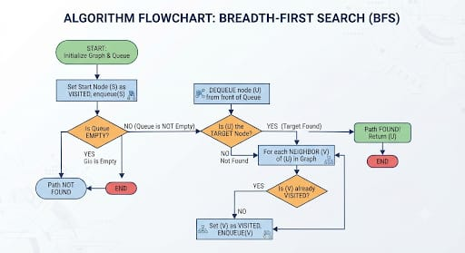

PYTHON CODE
from collections import deque

graph = {}

n = int(input("Enter number of nodes: "))

for i in range(n):
node = input("Enter node: ")
neighbors = input("Enter neighboring nodes separated by space: ").split()
graph[node] = neighbors

start = input("Enter starting node: ")
goal = input("Enter goal node: ")

queue = deque([[start]])
visited = set()

while queue:
path = queue.popleft()
node = path[-1]

if node == goal:
print("BFS Path:", " -> ".join(path))
break

if node not in visited:
visited.add(node)

for neighbor in graph.get(node, []):
if neighbor not in visited:
new_path = path + [neighbor]
queue.append(new_path)
else:
print("Goal node not found.")

OUTPUT
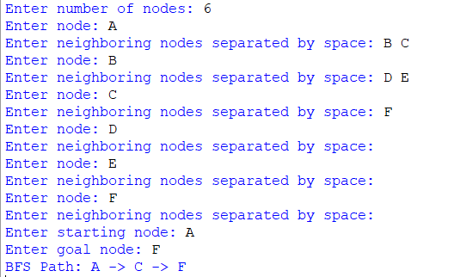

Result
The BFS algorithm successfully found the shortest path from the starting node to the goal node.
Conclusion
The Breadth First Search algorithm successfully traversed the graph level by level and found the goal node using a queue-based approach.

